Face opening 426 x 60
Text box 400 x 40
TOTAL SPACES PER LINE: 24

https://fontmeme.com/pixel-fonts/
register 50

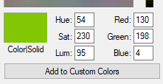


CALL KEY 4 ALERT
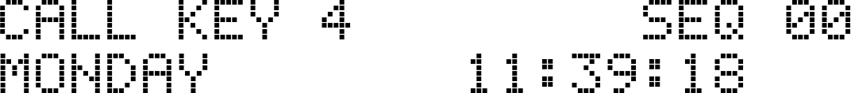

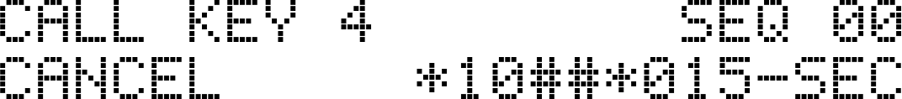

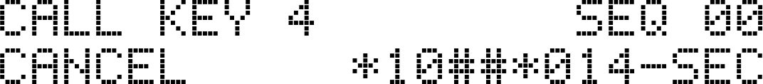

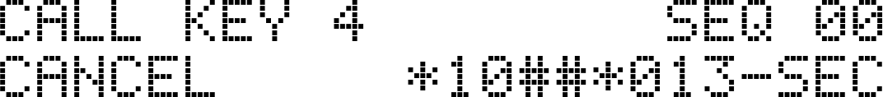

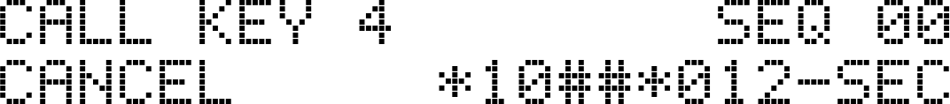

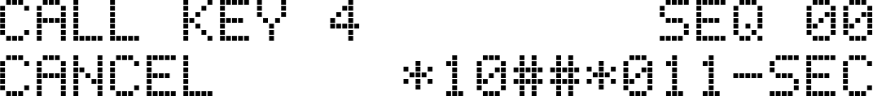

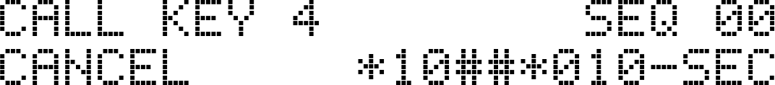



































CALL KEY 2

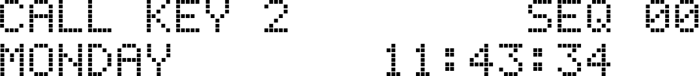

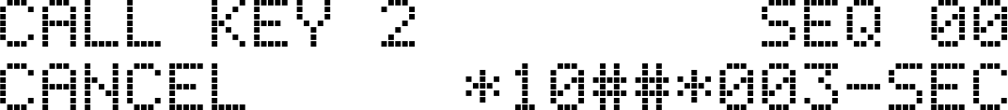
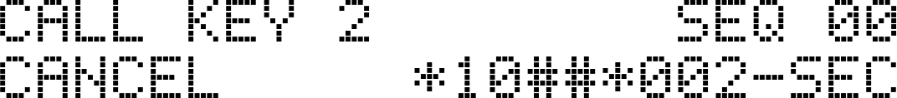

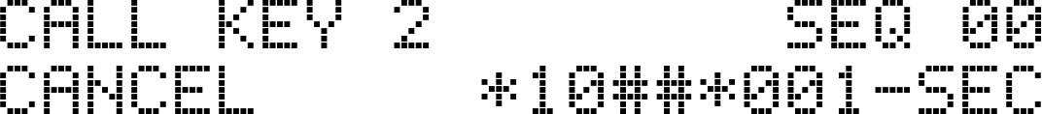

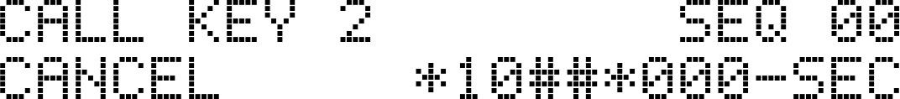










MANUAL INPUT

